|  |  |  |  |  |  |  |  |  |
| --- | --- | --- | --- | --- | --- | --- | --- | --- |
| Subject code | : | CE143 | Semester | : | 1 | Academic Year | : | 2023-2024 |
| Subject name | : | Computer Concepts and Programming | | | | | | |

**Instructions for Coding standards:**

* First line in any program must be “/* This program is prepared by 23TCE0XX_Name */”.
* Understand the problem and draw the flowchart for planned solution and write algorithm.
* **Indentation:** Ensure proper indentation in code.
* **Naming Conventions:** Ensure appropriate naming conventions for variables (CamelCase is mandatory).
* **Comments:** Ensure single line or multiline comments in code.
* Habituate yourself for revising code in order to solve errors.

**Essential symbols for flowchart:** [Students may use additional structures in certain cases to increase knowledge transfer]

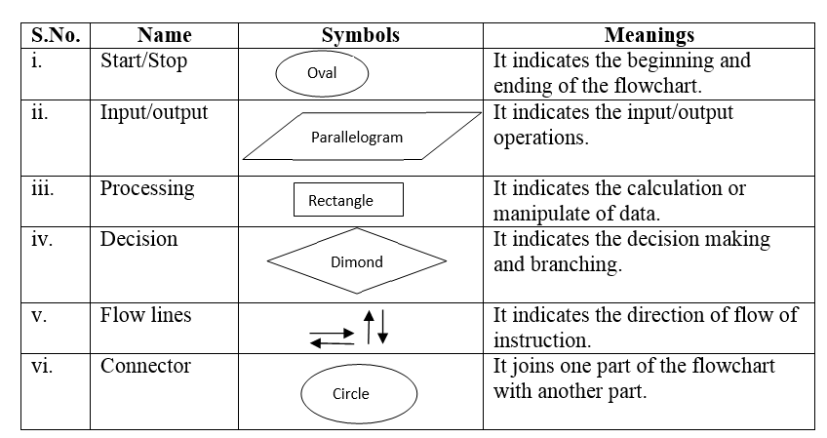

**Rubrics:**

|  |  |  |  |
| --- | --- | --- | --- |
| **Criteria** | **Excellent 5** | **Good 3** | **Poor 1** |
| Flowchart and Algorithm | Ensured correct use of Flowchart symbols, also flow of solution and algorithm are matching | Correct use of flowchart symbols but mismatch in flowchart and algorithm | Either Flowchart or Algorithm is missing |
| Coding Standards  (Naming Conventions,  Indentation, Comments) | All 3 ensured | Any two ensured | Any one ensured |
| Output as per Expectation  (Attach output screenshot and filled the table) | Attached screenshot of output and filled the table | Attached screenshot of output but not filled the table | Neither Screenshot attached nor filled the table |
| Question and Answer | Questions are answered appropriately and are well formatted | Minor mistakes in answers and moderately formatted | Either not answered or clarity of answer is not apparent |

|  |  |
| --- | --- |
|  | **Practical Set 1** |
| **Program: 1.1** | **Write a simple Program to print “Hello World” using notepad.** |
| **Flowchart** |  |
| **Algorithm** | Step 1: Start  Step 2: Print "Hello World" to the standard output.  Step 3: End |
| **Code** |  |
| **Output** |  |
|  |  |

Sign: Grade:

|  |  |
| --- | --- |
|  | **Practical Set 1** |
| **Program: 1.2** | Write a C program that will output this passage by Michael Singer. Use Required Escape Sequence and ASCII Value. |
| **Flowchart** |  |
| **Algorithm** | Step 1: Start  Step 2: Print "Hello World" to the standard output.  Step 3: End |
| **Code** |  |
| **Output** |  |
|  |  |

Sign: Grade:

|  |  |
| --- | --- |
|  | **Practical Set 1** |
| **Program: 2.1** | Write a C program that will output this passage by Michael Singer. Use Required Escape Sequence and ASCII Value. |
| **Flowchart** |  |
| **Algorithm** | Step 1: Start  Step 2: Print "Hello World" to the standard output.  Step 3: End |
| **Code** |  |
| **Output** |  |
|  |  |

Sign: Grade:

|  |  |
| --- | --- |
|  | **Practical Set 1** |
| **Program: 2.2** | Write a C program that will output this passage by Michael Singer. Use Required Escape Sequence and ASCII Value. |
| **Flowchart** |  |
| **Algorithm** | Step 1: Start  Step 2: Print "Hello World" to the standard output.  Step 3: End |
| **Code** |  |
| **Output** |  |
|  |  |

Sign: Grade:

|  |  |
| --- | --- |
|  | **Practical Set 1** |
| **Program: 3.1** | Write a C program that will output this passage by Michael Singer. Use Required Escape Sequence and ASCII Value. |
| **Flowchart** |  |
| **Algorithm** | Step 1: Start  Step 2: Print "Hello World" to the standard output.  Step 3: End |
| **Code** |  |
| **Output** |  |
|  |  |

Sign: Grade:

|  |  |
| --- | --- |
|  | **Practical Set 1** |
| **Program: 3.2** | Write a C program that will output this passage by Michael Singer. Use Required Escape Sequence and ASCII Value. |
| **Flowchart** |  |
| **Algorithm** | Step 1: Start  Step 2: Print "Hello World" to the standard output.  Step 3: End |
| **Code** |  |
| **Output** |  |
|  |  |

Sign: Grade:

|  |  |
| --- | --- |
|  | **Practical Set 1** |
| **Program: 3.3** | Write a C program that will output this passage by Michael Singer. Use Required Escape Sequence and ASCII Value. |
| **Flowchart** |  |
| **Algorithm** | Step 1: Start  Step 2: Print "Hello World" to the standard output.  Step 3: End |
| **Code** |  |
| **Output** |  |
|  |  |

Sign: Grade:

|  |  |
| --- | --- |
| **Program: 4.1** | Write a C program that will output this passage by Michael Singer. Use Required Escape Sequence and ASCII Value. |
| **Flowchart** |  |
| **Algorithm** | Step 1: Start  Step 2: Print "Hello World" to the standard output.  Step 3: End |
| **Code** |  |
| **Output** |  |
|  |  |

Sign: Grade:

|  |  |
| --- | --- |
|  | **Practical Set 1** |
| **Program: 5.1** | Write a C program that will output this passage by Michael Singer. Use Required Escape Sequence and ASCII Value. |
| **Flowchart** |  |
| **Algorithm** | Step 1: Start  Step 2: Print "Hello World" to the standard output.  Step 3: End |
| **Code** |  |
| **Output** |  |
|  |  |

Sign: Grade:

|  |  |
| --- | --- |
|  | **Practical Set 1** |
| **Program: 5.2** | Write a C program that will output this passage by Michael Singer. Use Required Escape Sequence and ASCII Value. |
| **Flowchart** |  |
| **Algorithm** | Step 1: Start  Step 2: Print "Hello World" to the standard output.  Step 3: End |
| **Code** |  |
| **Output** |  |
|  |  |

Sign: Grade:

|  |  |
| --- | --- |
|  | **Practical Set 1** |
| **Program: 5.3** | Write a C program that will output this passage by Michael Singer. Use Required Escape Sequence and ASCII Value. |
| **Flowchart** |  |
| **Algorithm** | Step 1: Start  Step 2: Print "Hello World" to the standard output.  Step 3: End |
| **Code** |  |
| **Output** |  |
|  |  |

Sign: Grade:

|  |  |
| --- | --- |
|  | **Practical Set 1** |
| **Program: 5.4** | Write a C program that will output this passage by Michael Singer. Use Required Escape Sequence and ASCII Value. |
| **Flowchart** |  |
| **Algorithm** | Step 1: Start  Step 2: Print "Hello World" to the standard output.  Step 3: End |
| **Code** |  |
| **Output** |  |
|  |  |

Sign: Grade:

|  |  |
| --- | --- |
|  | **Practical Set 1** |
| **Program: 5.5** | Write a C program that will output this passage by Michael Singer. Use Required Escape Sequence and ASCII Value. |
| **Flowchart** |  |
| **Algorithm** | Step 1: Start  Step 2: Print "Hello World" to the standard output.  Step 3: End |
| **Code** |  |
| **Output** |  |
|  |  |

Sign: Grade: